

Hypertrophic Cardiomyopathy
What Is Hypertrophic Cardiomyopathy?
Hypertrophic cardiomyopathy (HCM) is the most common heart disease in cats. HCM is a disease where the muscular walls of the ventricles become abnormally thickened. The name hypertrophic cardiomyopathy literally means “thick heart muscle disease” (Figure 1 below).
While many purebred cats (such as American shorthair, Maine Coons, Ragdolls, and Persians) are predisposed to the disease, the domestic short hair (regular house cat) is most commonly diagnosed with HCM. Cats are usually middle aged to older; however, it can be diagnosed at any age. No viral or nutritional causes of HCM have been identified in cats. 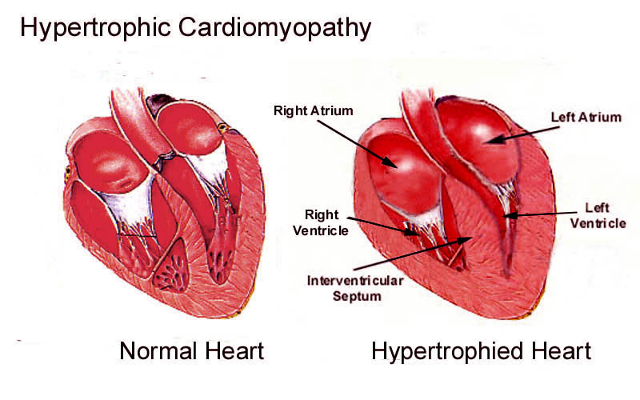
Figure 1. On the left is a graphic representation of a normal left ventricle and on the right is an enlarged left ventricle as noted in hypertrophic cardiomyopathy.
What Are the Symptoms of Feline Heart Disease?
Often, heart disease will develop over a period of time, but symptoms may not become apparent until the condition has progressed. This is partly due to the fact that heart disease tends to cause slow changes in the body, as well as the fact that cats are very good at hiding illness. It is important to recognize the warning signs of this disease so that treatment can be started as soon as possible. Some of the symptoms exhibited can include weight loss and loss of appetite. Weakness, listlessness, and lack of interest in exercise are also quite typical. Other signs are difficulty breathing and shortness of breath. As an owner of a cat with HCM, you should be very sensitive to changes in your pet's condition and should not hesitate to seek veterinary advice.

What Are the Consequences of the Thickened Left Ventricle?
The degree to which the muscle walls thicken ultimately determines the severity of the disease – some cats have mild disease, others have severe disease. As HCM progresses, the structure and function of the heart is altered. This may ultimately result in fluid being forced into the lungs and chest cavity (commonly called “congestive heart failure,”). In some cats, the thickening leads to arrhythmias and can result in sudden death. Other cats can suffer from blood clots in the aorta that cause a blockage of blood flow to the back legs, leading to sudden paralysis, severe pain, and often, death.
How is HCM Diagnosed?
Physical examination can often reveal clues of heart disease. An increased heart rate, heart murmur, and/or gallop rhythm (extra heart sound) may be detected as the disease advances.
An echocardiogram (ultrasound of the heart) offers the best means to diagnose HCM. Ultrasound shows the structure and function of the heart. Fortunately, the test is non-invasive and poses no risk to the cat. Radiographs provide additional useful information, but cannot be used alone to diagnose the disease.
As previously mentioned, additional tests (such as blood pressure and bloodwork) should be performed prior to starting any medications and to rule out underlying diseases such as systemic hypertension or hyperthyroidism.
How is HCM Treated?
Currently, there is no cure for HCM. The changes occurring to the heart muscle are irreversible. Therapy to improve heart function is available and there are two classes of medications commonly used. Most cardiologists agree that cats diagnosed with HCM should receive one or the other as part of their management. Response to therapy determines dose adjustment, changing of drug class, or discontinuation of therapy. Whether cats without symptoms will benefit from treatment is determined by their response to treatment. If there is significant improvement in the first 2 to 4 months, then therapy should definitely continue. There are additional medications that might be prescribed in the event of heart failure or clot development.
What Is the Prognosis?
The prognosis of a cat with HCM is highly variable. Some cats may develop only mild thickening and suffer little compromise of heart function, while others progress to more severe disease. HCM may worsen quickly over a period of months or slowly over several years. Its severity may not change for many years and then suddenly worsen. Some cats with HCM die very suddenly even though they had no clinical signs of heart disease.
A cat with mild to moderate disease may enjoy an essentially normal life for years. However, the prognosis is much more guarded with more severe disease. The risk of developing congestive heart failure is proportional to disease severity. Although congestive heart failure can be treated medically, it may become difficult to manage over time as the disease progresses. The prognosis for a cat with heart failure, unfortunately, is guarded to poor.

